Experiment 4

**Inverted index challenging exercise**

Web scrapping documents and create Inverted Index after nessesary preprocessing

|  |  |  |  |  |  |
| --- | --- | --- | --- | --- | --- |
| **Name:** | **:** | **Abhishek N N** | **Register No** | **:** | **20BCE1025** |
| Faculty | : | Dr. Alok Chauhan | Slot | : | L51-L52 AB1-605B |
| Course | : | Web Mining Lab | Code | : | CSE3024 |
| Programme | : | B.Tech CSE Core | Semester | : | Win – 22 - 23 |



**Problem- 1:**

Collect any 10 documents (English text documents) from the web and create inverted index by doing necessary preprocessing steps using python.

# preprocessing

# import the necessary libraries

import string

import nltk

import re

def text_lowercase(text):

return text.lower()

# Remove numbers

def remove_numbers(text):

result = re.sub(r'\d+', '', text)

return result

# remove punctuation

def remove_punctuation(text):

translator = str.maketrans('', '', string.punctuation)

return text.translate(translator)

# remove whitespace from text

def remove_whitespace(text):

return " ".join(text.split())

# remove stopwords

def remove_stopwords(text):

stopword_list = nltk.corpus.stopwords.words('english')

tokens = nltk.word_tokenize(text)

tokens = [token.strip() for token in tokens]

return ' '.join([token for token in tokens if token not in stopword_list])

# stemming

def stem_text(text):

ps = nltk.PorterStemmer()

tokens = nltk.word_tokenize(text)

tokens = [token.strip() for token in tokens]

return ' '.join([ps.stem(token) for token in tokens])

# lemmatization

def lemmatize_text(text):

wnl = nltk.WordNetLemmatizer()

tokens = nltk.word_tokenize(text)

tokens = [token.strip() for token in tokens]

return ' '.join([wnl.lemmatize(token) for token in tokens])

# remove special characters

def remove_special_characters(text):

pattern=r'[^a-zA-z0-9\s]'

text=re.sub(pattern,'',text)

return text

# remove extra newlines

def remove_extra_newlines(text):

pattern=r'[\r|\n|\r]+'

text=re.sub(pattern,' ',text)

return text

# apply all the functions to the text

def preprocess(corpus):

normalized_corpus = []

# normalize each document in the corpus

for doc in corpus:

doc = text_lowercase(doc)

doc = remove_numbers(doc)

doc = remove_punctuation(doc)

doc = remove_whitespace(doc)

doc = remove_special_characters(doc)

doc = remove_extra_newlines(doc)

doc = lemmatize_text(doc)

doc = stem_text(doc)

doc = remove_stopwords(doc)

normalized_corpus.append(doc)

return normalized_corpus

# inverted index

def generateInvertedIndexDict(dataFromDoc: list[str]) :

d=dict()

termsListFromDoc = [s.split() for s in dataFromDoc]

for docId, termList in enumerate(termsListFromDoc):

for term in termList:

if term not in d:

d[term]={docId}

else:

d[term].add(docId)

return d

# file handling

from os import listdir

from os.path import isfile, join

def getDataFromDocs(dir):

"""

gets strings from docs

parameters:

dir (str) : directroy which contains all files

return:

list of str read from docs in the directory given by user

"""

return [open(join(dir, f)).read() for f in sorted(listdir(dir)) if isfile(join(dir, f))]

def getDocIDToDocNameMap(dir):

"""

gets the map of docID to docName

parameters:

dir (str) : directroy which contains all files

return:

dict of docID to docName of docs in the directory given by user

"""

return {i:x for i, x in enumerate([f for f in sorted(listdir(dir)) if isfile(join(dir, f))])}

from urllib.request import urlopen

urls=[

"https://shakespeare.folger.edu/downloads/txt/the-winters-tale_TXT_FolgerShakespeare.txt",

"https://shakespeare.folger.edu/downloads/txt/venus-and-adonis_TXT_FolgerShakespeare.txt",

"https://shakespeare.folger.edu/downloads/txt/the-two-noble-kinsmen_TXT_FolgerShakespeare.txt",

"https://shakespeare.folger.edu/downloads/txt/the-two-gentlemen-of-verona_TXT_FolgerShakespeare.txt",

"https://shakespeare.folger.edu/downloads/txt/twelfth-night_TXT_FolgerShakespeare.txt",

"https://shakespeare.folger.edu/downloads/txt/troilus-and-cressida_TXT_FolgerShakespeare.txt",

"https://shakespeare.folger.edu/downloads/txt/titus-andronicus_TXT_FolgerShakespeare.txt",

"https://shakespeare.folger.edu/downloads/txt/timon-of-athens_TXT_FolgerShakespeare.txt",

"https://shakespeare.folger.edu/downloads/txt/the-tempest_TXT_FolgerShakespeare.txt",

"https://shakespeare.folger.edu/downloads/txt/romeo-and-juliet_TXT_FolgerShakespeare.txt"

]

l=[]

for url in urls:

textPage = urlopen(url)

l.append(textPage.read())

# inverted index becomes to long so took only first 100 characters

for i in range(len(l)):

l[i]=str(l[i])[:100]

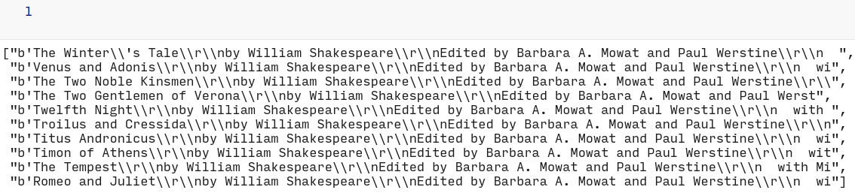

preprocessed_text=preprocess(l)

preprocessed_text

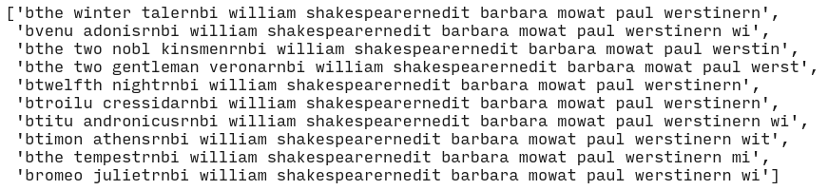

generateInvertedIndexDict(preprocessed_text)

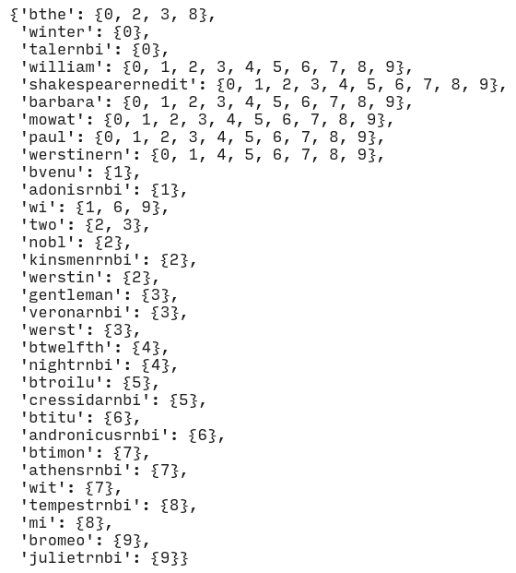

**Challenging Exercise-1:**

Collect any 10 documents (Indian Language text Documents in Unicode) from the web and create inverted index by doing necessary preprocessing steps using python.

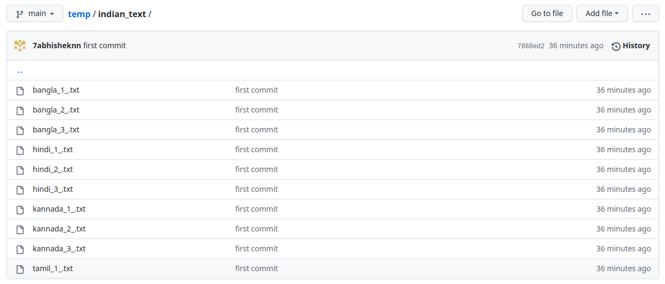

# direct web link to indian text file was not there so i made github folder containing files

urls=[

"https://raw.githubusercontent.com/7abhisheknn/temp/main/indian_text/bangla_1_.txt",

"https://raw.githubusercontent.com/7abhisheknn/temp/main/indian_text/bangla_2_.txt",

"https://raw.githubusercontent.com/7abhisheknn/temp/main/indian_text/bangla_3_.txt",

"https://raw.githubusercontent.com/7abhisheknn/temp/main/indian_text/hindi_1_.txt",

"https://raw.githubusercontent.com/7abhisheknn/temp/main/indian_text/hindi_2_.txt",

"https://raw.githubusercontent.com/7abhisheknn/temp/main/indian_text/hindi_3_.txt",

"https://raw.githubusercontent.com/7abhisheknn/temp/main/indian_text/kannada_1_.txt",

"https://raw.githubusercontent.com/7abhisheknn/temp/main/indian_text/kannada_2_.txt",

"https://raw.githubusercontent.com/7abhisheknn/temp/main/indian_text/kannada_3_.txt",

"https://raw.githubusercontent.com/7abhisheknn/temp/main/indian_text/tamil_1_.txt",

]

l=[]

for url in urls:

textPage = urlopen(url)

l.append(textPage.read().decode('utf-8'))

l

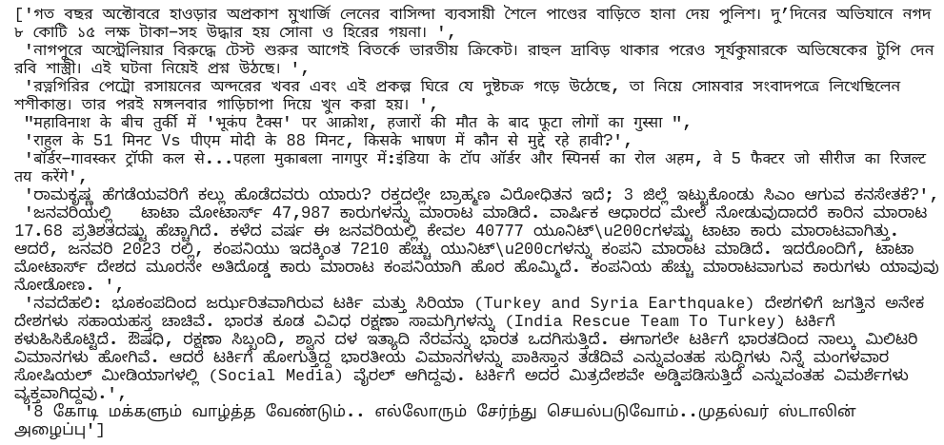

# since the data is indian we cannot apply all preprocessing steps

def preprocess_indian_text(corpus):

normalized_corpus = []

# normalize each document in the corpus

for doc in corpus:

doc = remove_numbers(doc)

doc = remove_punctuation(doc)

doc = remove_whitespace(doc)

doc = remove_extra_newlines(doc)

normalized_corpus.append(doc)

return normalized_corpus

preprocessed_text=preprocess_indian_text(l)

preprocessed_text

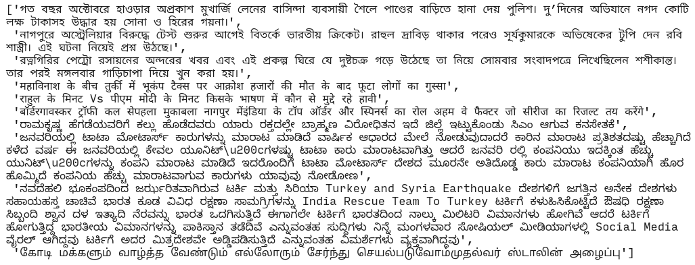

generateInvertedIndexDict(preprocessed_text)

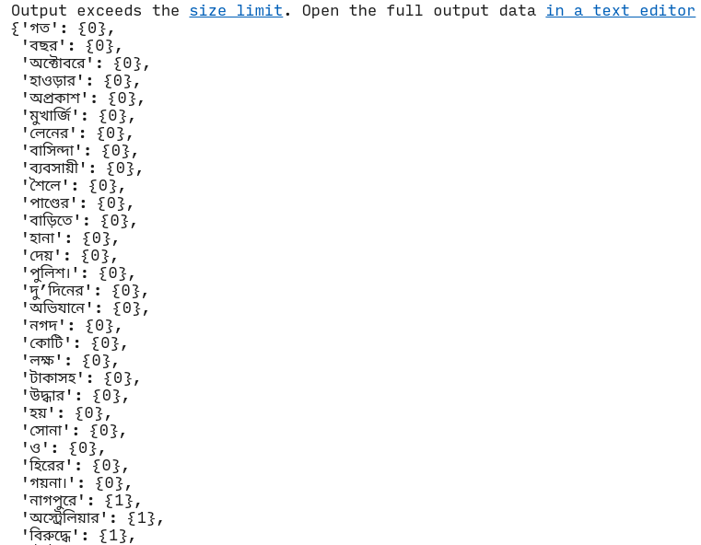

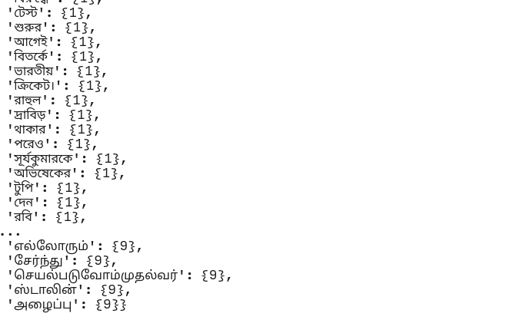

**Challenging Exercise-2:**

Collect any 10 documents (Documents in different formats such as PDF, DOC, ODF) from the web and create inverted index by doing necessary preprocessing steps using python.

import requests

import textract

urls=[

"https://github.com/7abhisheknn/temp/raw/main/different_format_documents/1.odt",

"https://github.com/7abhisheknn/temp/raw/main/different_format_documents/2.odt",

"https://github.com/7abhisheknn/temp/raw/main/different_format_documents/3.odt",

"https://github.com/7abhisheknn/temp/raw/main/different_format_documents/4.odt",

"https://github.com/7abhisheknn/temp/raw/main/different_format_documents/1.docx",

"https://github.com/7abhisheknn/temp/raw/main/different_format_documents/2.docx",

"https://github.com/7abhisheknn/temp/raw/main/different_format_documents/3.docx",

"https://github.com/7abhisheknn/temp/raw/main/different_format_documents/1.pdf",

"https://github.com/7abhisheknn/temp/raw/main/different_format_documents/2.pdf",

"https://github.com/7abhisheknn/temp/raw/main/different_format_documents/3.pdf",

]

l=[]

for url in urls:

response = requests.get(url)

saveFile=""

if (url[-3:]=="odt"):

saveFile="temp.odt"

elif (url[-3:]=="ocx"):

saveFile="temp.docx"

else:

saveFile="temp.pdf"

open(saveFile, "wb").write(response.content)

text = textract.process(saveFile)

l.append(text)

l

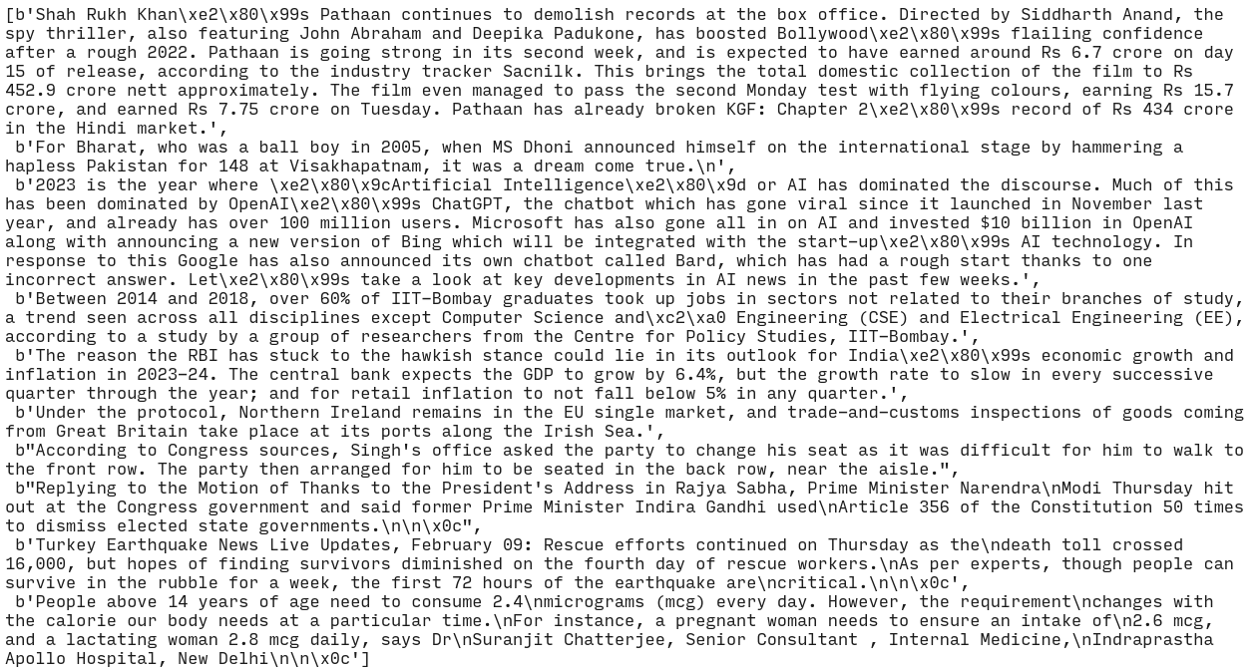

for i in range(len(l)):

l[i]=str(l[i])

preprocessed_text=preprocess(l)

preprocessed_text

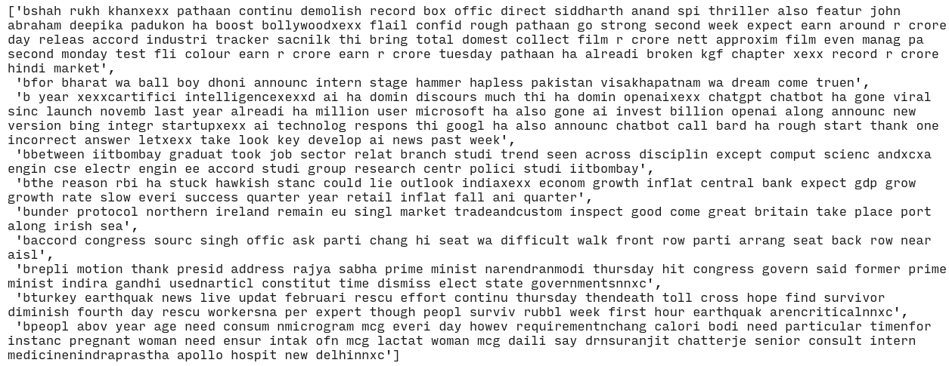

generateInvertedIndexDict(preprocessed_text)

